**Project Plan**

**For Zodiac Music Toy Development**

Created by Lianyin Li

Version 1.3

03/01/2014

**Document history:**

| **Version** | **Date** | **Changed by** | **Change (What is changed)** | **Approved by** | **Reviewed by** |
| --- | --- | --- | --- | --- | --- |
| V1.0 | March 1 2014 |  |  |  | Anisweta  Sinha |
| V1.1 | March 13 2014 | Lianyin | 1 Add descriptions for features.  2 update the second scenario.  3 update the risk2 |  | Anisweta  Sinha  Michael Koenig |
| V1.2 | March 14 2014 | Lianyin | 1 Copy paste schedule in 6.2  2 update the scenarios that should meet with features. |  |  |
| V1.3 | March 14 2014 | Lianyin | 1 add wire-frames for software  2 put risks into a table. |  |  |

Contents

1 Introduction 4

1.1 Background 4

1.2 Vision &Scope 4

1.3 Personas 6

2 Features 9

2.1 Scenarios 10

2.2 User stories 13

2.3 Wire-frames 14

3 WBS 17

4 Staffing plan 19

5 Estimations 19

6 Schedule 21

6.1 Top-down 21

6.2 Bottom-up 23

6.3 Critical Path Analysis 23

7 Risk Managements 24

8 Budget 24

# Introduction

## Background

Good sleep is so important for babies. When they are sleeping, the brains get development and they will consolidate everything they received in the daytime. If the babies do not get good sleep at night for some days, it will drive their parent to crazy. Parents want their babies get healthy sleep. Some research reports lullabies works well to help babies fall in sleep easily and fast. However, each baby is different from others. They have their own favorite songs and sleeping pattern. Some loves bird’s sound, some love noise like the sound of hairdryer. Parents hope their baby has a special music toy that can customize based on baby’s love or dislike. However, in current market, there are few lullabies toys. The popular one is seahorse that pre-set five to eight lullabies in, but it cannot support to add more or delete music. It does not meet with parents’ needs really.

The new zodiac animal music toy of S company is the right one for these parents. It is four-in-one: toy, media player, recorder and light. It is for 6 months old and up kids. For kids, it is a beautiful animal toy with soft fur. It attracts babies’ attention by eyes opening and closing, and it contains beautiful music/ lullabies. It is safe for kid anytime (to hold when they are sleeping and safe for biting, etc.); for parents. It is an effective tool to get the kid off the bed. It is a media player; it support to add/delete the music/songs, support MP3 and can adjust the volume and set playlist and the period of music playing time; at the same time, it is a recorder, too. Parents use it to record their babies’ voice and their babbling; it can be changed light brightness and colors. In addition, it is easy to clear.

## Vision &Scope

### Vision

After it launches to market, it should be the bestseller in 3 months and should become the most favorite toy of children. On the famous online shopping websites, it should be at least four stars rating.

### In of Scope

### This product appearance looks like zodiac animals. Twelve animals look different by changing the covers.

### The surface/covers are polyester fiber. The surface/cover can be taken off and washable by hand or machine and dry wash. All components are BPA free and toxic free.

### This product uses 3 AA batteries.

### This product can connect to computer with USB port.

### Its memory space can be 2G, 4G and 8G.

### This product should work normally during -20 ℃ ~50 ℃.

1. The followed features should be included.

* Toy’s size is 5 x 5 x 10.5 inches, weight is 15 ounces or less.
* The eyes of animal can close and open when changing its posture. When they lay down, eyes are closed; else, they are opening.
* Screen size is 1 x 1.5 inches.
* Media player functions. It can add/delete the music/songs, support MP3 no other format music files and can adjust the volume and set playlist and the period of music playing time.
* Recorder functions. It can use to recorder babies’ voice and their babbling; do not support recording images. Size of each record file depends on the memory space.
* It can change light brightness and colors.
* Languages should be set based on the countries that the toy launches.

### Pass software and hardware test and safety test. Provide the certification of safety if applicable.

### Provide user manuals in English, Spanish, and Chinese.

### Product release date is August 30; delivery date is November 1 2014 to popular websites like Amazon and stores like Walmat, Target.

### Out of Scope

### Cotton, silk or other material for cover except polyester fiber

### This product supports the re-charge or [Button Cell Batteries](https://www.google.com/shopping/product/1070093682451926995?q=button+battery&client=firefox-a&hs=blP&rls=org.mozilla:en-US:official&channel=np&bav=on.2,or.r_cp.r_qf.&bvm=bv.60983673,d.cGU,pv.xjs.s.en_US.jnH77UlIqKE.O&biw=1280&bih=696&tch=1&ech=1&psi=3Pz7UsGnHJPmoASwvYKAAg.1392245981664.3&sa=X&ei=4vz7UuryG8zboATs94J4&ved=0CN0EEPMCMAI)

### Support plug to electric.

### This product provides Com port or other ports.

### Support other format music files except MP3.

### Support other languages to display information on screen except English.

### Training materials

### Record image(s)

### Music player supports forward or backward play.

### Edit MP3 or record file(s).

### Camera functions.

### The product works in water or fire.

## Personas

### Lily Smith



Twenty-seven year-old Lily is the mother of one girl Kate who is 1-year-old. She lives in her own home, cooks very day and bakes a pie once or two a month. She loves cooking and makes food for her baby and husband. Sometimes she invites some friends and treats them lunch or dinner with delicious food and cookies. She loves animals. She had cats, dogs, rabbits when she was a child. Before the baby was born, Lily loves to play card games. Every Friday night, she asked her friends to join and play the cards. Moreover, she loves to see movies with her husband. However, baby’s coming changed her life a lot. She and her husband have one trip or two to other countries for the vocations. Last year they went to Hawaii. This year they are going to Aegean Sea with her baby, she is going to bring her baby’s favorite toy and portable crib that baby is using. She hopes these can comfort her baby when baby get fussy during the trip.

Lily is a student, too. She has two courses on campus and one on-line. Her mayor is accounting. After baby sleeps, Lily starts to prepare the assignments of courses. She took participate in a party organized by her Chinese classmates this month. She was so happy when she knew her zodiac is Rabbit and she has a Tiger husband and a Dragon daughter and learn about the zodiac stories during the party. She loves shopping, too. She is an on-line shopping fan. She has at least ten credits cards. She buys fashion clothes, and many toys for her baby. Her baby has some toys of animal, like turtle and dinosaur and bear. She orders two times or three on Amazon a month. She keeps her eyes on all kinds of deals. During the sales seasons like Black Friday and Christmas, she would buy many toys or gifts for her kid and children of friends’. She found her daughter loves music. When she plays music to her girl, the girl looks so happy, she will twist her waist and hip with the tempo, and white noise makes her baby falling into sleep easily and quickly. Moreover, she bought music table and Seahorse for Kate. However, she realizes these toys meet with her daughter’s need partly. She is thinking it is better if there is a toy that user can customize. For example, it can be added Kate’s favorite music/songs, delete those she does not like. Now her daughter tries to speak every day and sometime she always gives Lily surprise that Kate speak new words or new sounds. Lily hopes she can catch that moment and keeps them. However, most she missed since when she fetched the recorder or phone, Kate has done. Lily hopes her daughter has such toy that can be a recorder then she can record immediately and conveniently.

She is an internet fan, too. She spent at least 3 hours on the internet each day; reading /writing blog; reading news; researching some information about raising the baby; chatting with other moms online to share experiences with other moms.

Every Saturday morning, she and her husband with their girl go to supermarket to buy grocery, baby food and cats’ food for a week. If it is a good weather on Sunday, they take their girl to park nearby their home or meet their friends. She has some neighborhoods who have girls, too. Therefore, their girls can play together. Every Friday morning 11:30AM, she takes Kate to go to Redmond Library for story time. After that, Lily would borrow/return some books from/ to library for her kid. In addition, every Sunday afternoon 13:00PM she takes her girl to Redmond Gym play and learn center.

Lily feeds her baby bread milk when the baby need and two times solid at 12:00 and 18:00. It is not easy to feed the baby when the baby at this age. Every time the baby would get everywhere messy. Kate still keeps two naps in the daytime, one is 10:00 in the morning and other is 4:00 in the afternoon. Night o’clock, it is time to go to bed for Kate. Before her baby goes to naps or sleep, she plays with her for half an hour. Singing /playing songs/music; reading the book; playing game; playing toys, then lets the baby go to sleep alone. Lily uses baby monitor to know how baby is and does not worry to disturber the baby.

### Eileen Li

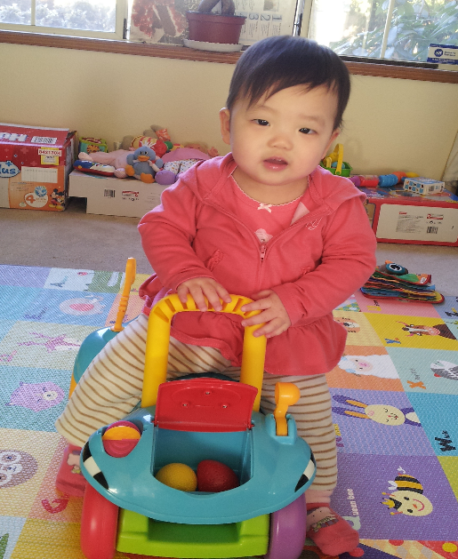

Eileen is a cute and active baby girl, 11 months old. She lives with her parents. Her house is full of her laughter. She loves cats. Cats love her, too. They sleep nearby Eileen and let her touch them even pulls their tails and hair. She loves “reading”. She always holds a book and keeps turning the pages, when she wake up in the morning or before she go to bed. She loves to tear up the books, newspaper, magazines, paper, too.

She is very curious. When she hears new sound or sees new things, she looks excited and wants to find out what is that. She always wants t to reach everything around her. She always watches the people. She love to smile at people who are familiar with her but cries when she met the strangers sometimes. She loves to go outside with her parents. In a warm and sunny day, her mother would take her outside; she is so happy and “talking” to her mother on the way.

Eileen plays with herself even though her parents invited the playmates who are at the same age with Eileen. She keeps a short time attention on a specific toy; she always changes her toys in hand. However, when she plays her music table, she plays for half an hour.

Eileen has four time milk at bout 8:00Am, 12:00AM, 16:00PM, 19:30PM and two times solid food at 12:00AM and 18:00PM a day. It is not easy to feed the baby when the baby is at this age. Every time the baby would get everywhere messy. She tries to grab the spoon and bowl, tries to feed her by herself when her mother feeds her solid food. Eileen has one nap or two in the daytime, one is about 10:00 in the morning if applicable and other is about 13:30 in the afternoon. Eileen always goes to bed at 20:00Pm. Her mother would give her a bath at 19:20 then feed her six, seven Oz milk before Eileen goes to sleep. Before Eileen falls in to sleep, her mother would stay with her, sometime singing songs quietly; sometime reading the books; sometime playing games or toys. Eileen has two favorite books: Hickory Dickey Dock and Mickey Mouse Club House. She always asks her mother read these books repeatedly. She would touch the figure with her nose or tongue when her mother is reading. Although Eileen does not know how to speak yet but she uses her own way to let the mother know her meanings. She would hold the book, passes to her mother’s hand, and says babbling. Her mother asks” Do we read this page?” Eileen would smiles and nods her head or claps her hands. Moreover, her favorite toys are Seahorse and [Tiny Love Sweet Island Dreams Mobile](http://www.amazon.com/Tiny-Love-Island-Dreams-Mobile/dp/B00198PQHY/ref=sr_1_1?s=baby-products&ie=UTF8&qid=1390372084&sr=1-1&keywords=mobile). She would hold the Seahorse and kisses it sometime. Sometime she bites it or tries to tear it up. Sometime she would pat the Seahorse slightly, since her mother pats on her slightly when she sleeps. Eileen would give it to her mother and would ask her mother to play music again when the Seahorse stops singing. In addition, she loves to throw things even though those are her love then requests her mother pick them up.

# Features

Zodiac music toy is four-in-one. It is toy; it is a media player, a recorder and a light.

### It is a cute zodiac animal toy, soft and warm.

### Music player functions: to play music/ songs

### Recorder functions: to record sound of the baby

### It is a night light with the weak brightness.

## Scenarios

### Scenarios& features

### Someday at noon, Eileen’s mom is going to prepare lunch for her baby and herself. She puts her baby on the play mat around with Center Safety Yard Pen in the family room that is near by the kitchen and she can have eyes on her baby while she is cooking; at the same time, Eileen can see her mother, too. A zodiac toy and other toys are around Eileen. Eileen picks up the Zodiac toy that is a cartoon snake in bright green cover and has a pair of big eyes that can close and open, and a long tail. She touches its eyes then pulls its tail. Sometime she try to tear the toy; sometime she slick the zodiac Snake ;sometime she throws it away then she crawls to pick up again. Suddenly, music is playing from the zodiac Snake since Eileen pushes the Play button. Eileen hears that and looks very curious. She holds the toys up and down, looks its face and looks back; try to find out what happen. When she hears her favorite songs, she is chuckling. Her mother smiles while she hears Eileen’s laugh.

Features:

1. Music/songs play
2. The eyes are open/ close
3. It’s safe to hold, touch, bite, slick and throw

### Kate is crying. Her mom Lily holds her and walks around the room, and pats on Kate’s back gently. However, it does not work. Kate is still crying. Kate does not speak yet. However, her mother knows she is not hungry since she just has some milk and is not sick. Therefore, she finds Kate’s favorite toy a zodiac Dragon and shows it to Kate and let the lullabies play. Kate notices the eyes of toy are close or open when her mother moves the toy. She stops crying and watches it for a while then starts to cry again. Lily thinks Kate feels boring about dragon, so she changes a dog cover instead of the dragon. Kate now laughs and stops crying. Though it does not work all the time but this time it did, it makes Kate calm her down and stop crying.

Features:

1. lullabies play
2. The eyes are open/ close
3. The cover can be changed then show as a different animal.

### A few months ago, Lily noticed a new toy named Zodiac animal sold well on Amazon and it got very good reviews and rating. One day Lily knew the toy can get 25% off. Lily puts an order for this toy. A few days later, she received a package from Amazon. She opened it and found a very cute zodiac Dragon in it. She read the manual first, starts to play the original music, but she did like them. Therefore, she connects the toy to computer with USB cable, deleted some music and copies lullabies to the toy. After that she create a playlist about lullabies and set 30 minutes playing time and other playlist about white noise with one hour playing time. In addition, she set when to fade out the sound and light followed the manual. She has done all. She put the toy into crib of her baby. She hope her little girl love this toy.

Features:

1. Can connect with computer with USB cable;
2. To copy lullabies or other music/songs to the toy
3. Delete the songs that she does not like.
4. Setting the playlist
5. Setting the period of time for each playlist
6. Setting when to fade out the sound and light brightness

### Helen is so crazy for her baby’s voice since her girl born. She tries to record every voice from her little girl. However, she always missed that moment. Her friend gave her baby a gift that is zodiac Horse toy and told her she can use it as a recorder. Her baby loves the toy and holds it all the time and wherever she goes. One thing she need to do is to press the tummy of the Horse for one second then the toy start to record when she tries to record some voice of her girl whatever the toy is playing music not. Helen is so happy she just recorded the first sound “mom” from her daughter a few minutes ago when her baby is playing with the toy playing music. Helen copied this file to her computer, saved, and erased some files she does not need any more.

Features:

1. Record sounds.
2. Playing music can be suspend when recording and after recording, it would resume.
3. Support copy /erase function.

### It is 7:00pm; Lily puts her baby Kate into crib after she gives her baby a warm bath and feeds her baby some milk. Lily picks up the zodiac toys (It is a dragon), selects lullabies playlist, presses the switch to play the lullabies then passes the dragon to Kate and turns off the light. Kate wants her mother plays with her; Kate passes the dragon back her mother then takes back again. On the other hand, she throws the dragon away and asks her mother picks up for her. Kate is active, always changes her position, sit, lay and stand up, But after half an hour. Kate starts to yawn and rub her eyes. Moreover, go to tummy and close her eyes. Lily puts dragon into Kate’s arm, and leave the room slightly. Kate holds the dragon into sleep, volume of lullabies and light fade out gradually after 10 minutes.

Features:

1. List all playlists.
2. Can choose playlist
3. lullabies play
4. Can adjust light brightness.
5. It is soft and warm.

## User stories

### As a kid, I want to play with the toy so that I feel comfortable and get funny.

Acceptance criteria:

1. Cartoon style, Beautiful appearance with bright colors
2. It is oft to the touch.
3. No potential risk for kids

For example, Small parts maybe fall off and cause choking when kids tear, or throw.

1. Maximum volume will not scare the babies.

### As a kid, I want to hold it when I am sleeping so that I feel warm and safety.

Acceptance criteria:

1. It is easy to hold for kids. Toy’s size is 5 x 5 x 10.5 inches, weight is 15 ounces or less.
2. Cartoon style, Beautiful appearance with bright colors
3. It is soft to the touch.
4. No potential risk for kids

For example, Small parts maybe fall off and cause choking when kids tear, or throw.

1. Maximum volume will not scare the babies.

### As a mom, I want to copy my baby’s favorite lullabies into the toy and add to sleeping music play list so that I can play these lullabies when it’s time to go to bed for my baby.

Acceptance criteria:

1. If there is no enough space, it should have warning message like “Lack of space”.
2. If copy complete, display “file(s) copy successfully”.
3. It can browse the files list.
4. If it reaches the maximum of songs in playlist when adding songs/music/lullabies, display the warming message “The maximum of songs in playlist is 5, please delete some files then try again.”
5. Can browse the playlist and see the copied file(s).

### As a mom, I want to play lullabies to my baby so that I smooth the baby let he/she calms down and fall into sleep easily.

Acceptance criteria:

1. If no playlist exist, it should have warning message like “please create a playlist first or play the lullabies directly”.
2. If there are some playlist, display all list of playlist.
3. Maximum volume will not scare the babies.
4. In the last few minutes of play (it can be setting), the volume and light will fade out gradually.

### As a mom, I want to record my baby’s babbling so that I can save and recall after years as a precious gift.

Acceptance criteria:

1. If there is no enough space, it should have warning message like “Lack of space”.
2. The record file is Mp3 format.
3. The record file allows copying and deleting.
4. Size of each record file depends on the memory space.
5. Select the recording, recording would suspend the musing playing, and after recording, music play resume.

## Wire-frames

### Covers

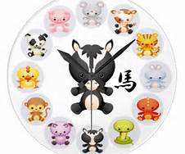

Features:

1. 12 zodiac animals
2. Covers can be changed
3. Light come from tummy
4. Eyes can close and open
5. Cover can be washable

### Body

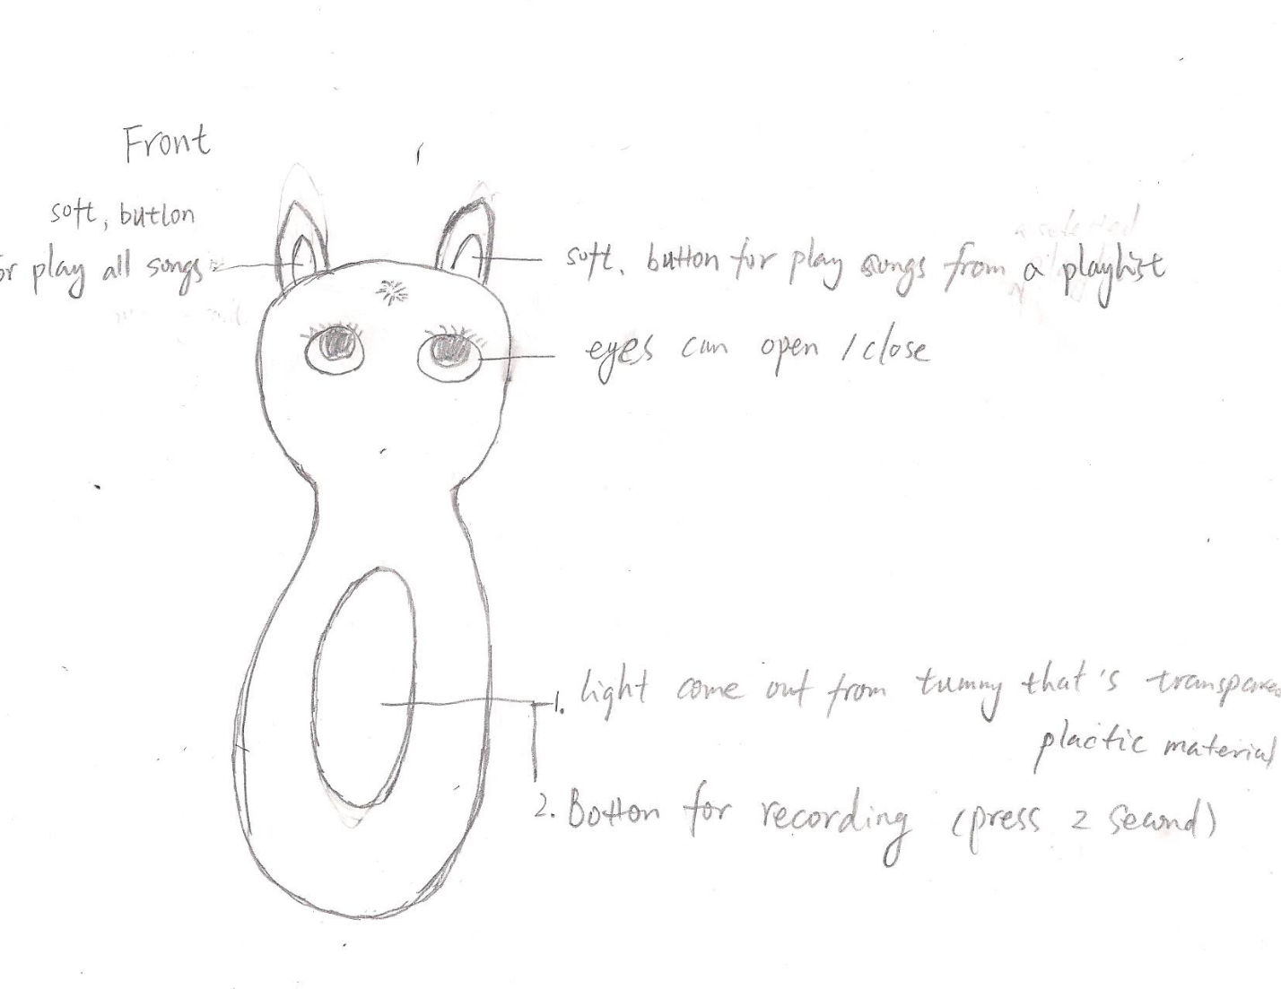

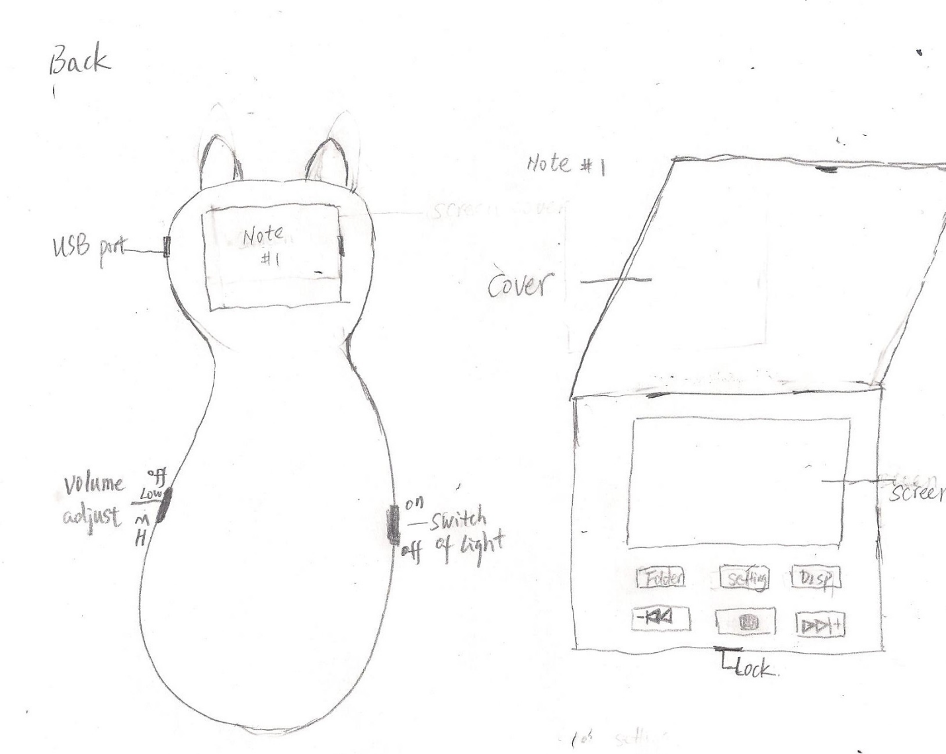

### Wire-frames of functions

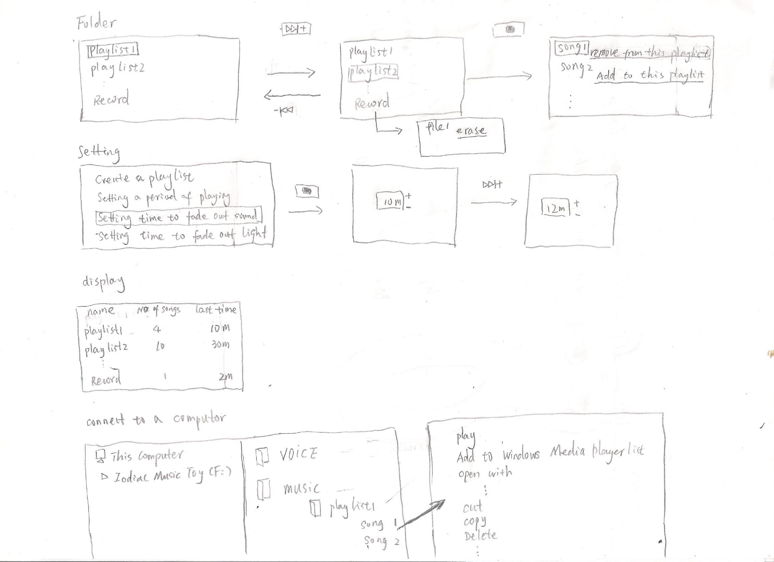

# WBS

|  |  |  |  |  |  |  |
| --- | --- | --- | --- | --- | --- | --- |
| Level 1 | Level 2 | Level 3 | Level 4 | prioritization | stack rank | Days |
|  |  |  | Zodiac Dragon design | High | 1 | 20 |
|  |  |  | Horse design | High | 2 | 10 |
|  |  |  | Tiger design | Medium | 29 | 10 |
|  |  |  | Monkey design | Medium | 30 | 7 |
|  |  | Twelve animals cartoon design | Pig design | Medium | 31 | 7 |
|  |  |  | Rabbit design | Medium | 32 | 7 |
|  |  |  | Sheep design | Medium | 34 | 7 |
|  |  |  | Snake design | Medium | 35 | 7 |
|  |  |  | Rooster design | Medium | 36 | 7 |
|  |  |  | Oxen design | Medium | 37 | 7 |
|  |  |  | Rat design | Medium | 38 | 7 |
|  |  |  | Dog design | Medium | 39 | 7 |
|  |  |  |  |  |  |  |
|  |  | Storage design |  | High | 22 | 4 |
|  |  | Screen design |  | High | 23 | 1 |
|  |  | Interface design |  | High | 24 | 5 |
|  |  | Music player circuit design |  | High | 25 | 7 |
|  | Hardware | Recorder circuit design |  | High | 26 | 7 |
|  |  | Light circuit design |  | Medium | 27 | 7 |
|  |  | light design |  | Medium | 28 | 3 |
| Zodiac Music Toy |  |  |  |  |  |  |
|  | Software | Music player | music plays functions | High | 3 | 7 |
|  |  |  | play setting | High | 13 | 5 |
|  |  |  | create playlist(s) | Medium | 8 | 5 |
|  |  |  | add music files into a playlist | Medium | 9 | 5 |
|  |  |  | remove the music files from a playlist | Medium | 10 | 5 |
|  |  |  | display playlists | Low | 11 | 5 |
|  |  |  | playlist selection | Low | 12 | 5 |
|  |  |  | copy music/songs | High | 4 | 5 |
|  |  |  | delete music/songs | High | 6 | 5 |
|  |  |  | sound fades out gradually | High | 7 | 5 |
|  |  |  | Volume adjust | High | 5 | 5 |
|  |  |  |  |  |  |  |
|  |  | Recorder | record | High | 14 | 10 |
|  |  |  | copy /move record files to computer | High | 16 | 5 |
|  |  |  | erase the record files | Medium | 17 | 5 |
|  |  |  | play record file | Low | 18 | 5 |
|  |  |  | Volume adjust | High | 15 | 5 |
|  |  |  |  |  |  |  |
|  |  | light | setting the color | low | 21 | 5 |
|  |  |  | setting the time to fade out | Medium | 20 | 5 |
|  |  |  | light fades out gradually | High | 19 | 5 |
|  |  |  |  |  |  |  |
|  |  | test | music plays functions | High | 40 | 4 |
|  |  |  | play setting | High | 50 | 4 |
|  |  |  | create playlist(s) | Medium | 43 | 3 |
|  |  |  | add music files into a playlist | Medium | 44 | 3 |
|  |  |  | remove the music files from a playlist | Medium | 45 | 3 |
|  |  |  | display playlists | Low | 46 | 3 |
|  |  |  | playlist selection | Low | 47 | 3 |
|  |  |  | copy music/songs | High | 41 | 3 |
|  |  |  | delete music/songs | High | 49 | 3 |
|  |  |  | sound fades out gradually | High | 48 | 3 |
|  |  |  | Volume adjust | High | 42 | 3 |
|  |  |  |  |  |  |  |
|  |  |  | record | High | 51 | 4 |
|  |  |  | copy /move record files to/from a computer | High | 53 | 3 |
|  |  |  | erase the record files | Medium | 54 | 3 |
|  |  |  | play record file | Low | 55 | 3 |
|  |  |  | Volume adjust | High | 52 | 3 |
|  |  |  |  |  |  |  |
|  |  |  | setting the color of light | low | 58 | 4 |
|  |  |  | setting the time to fade out | Medium | 57 | 3 |
|  |  |  | light fades out gradually | High | 56 | 3 |

# Staffing plan

|  |  |  |  |
| --- | --- | --- | --- |
| No. | Title | Headcount | Remarks |
|  | PM/PL | 1 (Steven) |  |
|  | Software Dev | 3 (James, Catharine, Dong) | One is senior only. (James) |
|  | Software Tester | 1 (Anna) |  |
|  | Hardware engineer/designer | 2 (Henry, Nedim) |  |
|  | Hardware tester | 1 (Robert) |  |
|  | Toy designer | 1 (Monika) |  |
|  | QA | 1 (Helena) | Senior |
|  | User manual writer | 1 (Jenna) | Part-time |
|  |  | Total: 11 |  |

# Estimations

|  |  |  |  |
| --- | --- | --- | --- |
| No. | Tasks | Days | Remarks |
|  | Twelve animals cartoon design | 20 | Design drawing; Dragon, Horse first |
|  | Toy body design | 15 | Design drawing |
|  | Interface design | 5 | design drawing and implement |
|  | Music player circuit design | 15 | design drawing and implement |
|  | Recorder circuit design | 15 | design drawing and implement |
|  | Light circuit design | 15 | design drawing and implement |
|  | light design | 3 | design drawing and implement |
|  | Music player functions design (software) | 7 | It should include design, document. |
|  | Recorder functions design (software) | 7 | It should include design, document, |
|  | light software control design (software) | 3 | It should include design, document, |
|  | music plays functions | 7 | It should include coding, unit test and bug fix. |
|  | play setting | 7 | It should include coding, unit test and bug fix. |
|  | create playlist(s) | 5 | It should include coding, unit test and bug fix. |
|  | add music files into a playlist | 5 | It should include coding, unit test and bug fix. |
|  | remove the music files from a playlist | 5 | It should include coding, unit test and bug fix. |
|  | display playlists | 5 | It should include coding, unit test and bug fix. |
|  | select playlist | 5 | It should include coding, unit test and bug fix. |
|  | copy music/songs | 5 | It should include coding, unit test and bug fix. |
|  | delete music/songs | 5 | It should include coding, unit test and bug fix. |
|  | sound fades out gradually | 5 | It should include coding, unit test and bug fix. |
|  | Volume adjust | 5 | It should include coding, unit test and bug fix. |
|  | record | 10 | It should include coding, unit test and bug fix. |
|  | copy /move record files to /from a computer | 5 | It should include coding, unit test and bug fix. |
|  | erase the record files | 5 | It should include coding, unit test and bug fix. |
|  | setting the color of light and time for fading out the light | 5 | It should include coding, unit test and bug fix. |
|  | light fades out gradually | 5 | It should include coding, unit test and bug fix. |
|  | Software test | 68 |  |
|  | Hardware test | 15 |  |
|  | User’s manual | 15 | English, Chinese and Spanish |
|  | Build toy model | 14 |  |
|  | Adjust product line | 14 |  |
|  | Product sample and test | 18 |  |
|  |  | Total: 318 |  |

# Schedule

## Top-down

|  |  |  |  |
| --- | --- | --- | --- |
| No. | Tasks | Start date | Remarks |
|  | Design body of toy | March 18 |  |
|  | Design covers of toy | April 8 | Dragon, Horse and sheep cartoon design only |
|  | Player circuit design | March 18 |  |
|  | Record circuit design | March 18 |  |
|  | Light design | April 8 |  |
|  | Player development | March 18 | Design, document, coding and unit test |
|  | Recorder development | March 18 | Design, document, coding and unit test |
|  | Light color and fade out control development | March 27 | Design, document, coding and unit test |
|  | Software test | March 18 |  |
|  | Hardware test | April 1 |  |
|  | Build toy model | April 1 |  |
|  | Product sample and test | May 9 |  |

## Bottom-up



## Critical Path Analysis

The critical path: Music player circuit design by Henry—software testing by Anna—product sample, E2E testing by Anna.

Note: The critical path is marked in red in above Gantt Char.

# Risk Managements

|  |  |  |  |
| --- | --- | --- | --- |
| **Risk** | **Probability** | **Impact** | **Mitigation** |
| Safety standard may be updated and become more stern; new science research maybe discover materials we applied have some facts which cause potential harm to babies. | Low | Product need get new safety certification. | Pay attention to the change of safety standard and the latest research results. Once the product could not meet with the new one, we should take actions like recall. |
| Hardware supplier announced they would close one of product-lines of circuit board and they would not product CB-Mxxx we are using for Zodiac music toy because of economic crisis. | Low | Extend the period of project: Product need new circuit board and import coding to new one. | Find a similar circuit board as soon as possible; that might reduce workload of import to new board. |

# Budget

|  |  |  |
| --- | --- | --- |
| No. | Items | Budget |
|  | Human Resource cost (Salary, allowance, office spend …) | $300,000 |
|  | Equipment (CPs, Simulators, tools, Circuit Boards …) | $50,000 |
|  | Software license(Win7, Office, CVS, Oracle if application … ) | $1000 |
|  |  | Total: $351000 |